**WEEK 6 HandsOn**

**Handson Task 5 :**

* **Style a react component**
* **Define styles using the CSS Module**
* **Apply styles to components using className and style properties**

**CODES AND OUTPUTS :**

1. **Unzip the react application in a folder**

**Open command prompt and switch to the react application folder**

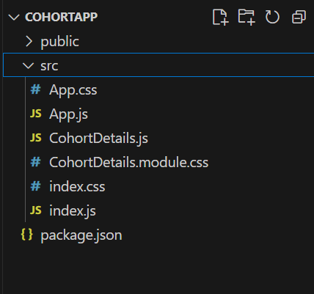

**3 .** **Restore the node packages using npm install**

**4.** Open the application using VS Code

1. Create a new CSS Module in a file called “CohortDetails.module.css”
2. Define a css class with the name as “box” with following properties

*Width = 300px;*

*Display = inline block;*

*Overall 10px margin*

*Top and bottom padding as 10px*

*Left and right padding as 20px*

*1 px border in black color*

*A border radius of 10px*

1. Define a css style for html <dt> element using tag selector. Set the font weight to 500.
2. Open the cohort details component and import the CSS Module
3. Apply the box class to the container div
4. Define the style for <h3> element to use “green” color font when cohort status is “ongoing” and “blue” color in all other scenarios.

**CohortDetails.module.css**

.box {

  width: 300px;

  display: inline-block;

  margin: 10px;

  padding: 10px 20px;

  border: 1px solid black;

  border-radius: 10px;

}

dt {

  font-weight: 500;

}

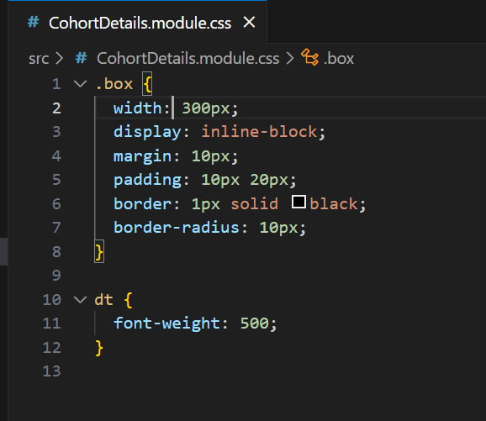

**CohortDetails.js**

import React from "react";

import styles from "./CohortDetails.module.css";

function CohortDetails({ name, status, startDate, endDate }) {

  const titleStyle = {

    color: status === "ongoing" ? "green" : "blue",

  };

  return (

    <div className={styles.box}>

      <h3 style={titleStyle}>{name}</h3>

      <dl>

        <dt>Status:</dt>

        <dd>{status}</dd>

        <dt>Start Date:</dt>

        <dd>{startDate}</dd>

        <dt>End Date:</dt>

        <dd>{endDate}</dd>

      </dl>

    </div>

  );

}

export default CohortDetails;

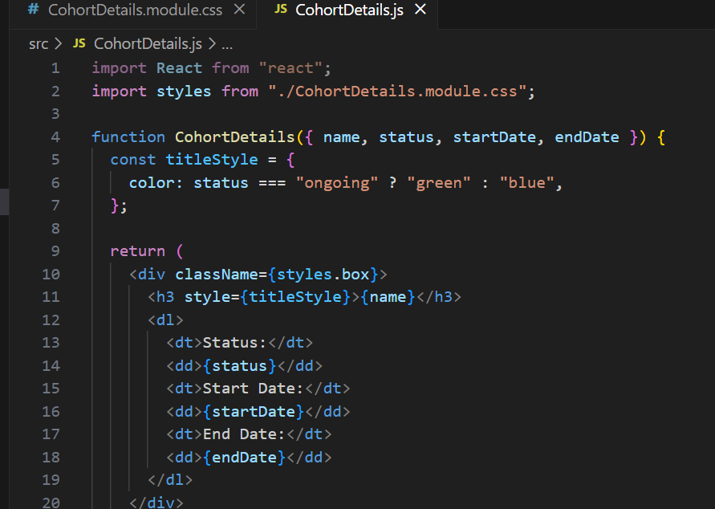

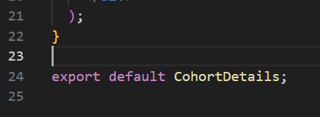

**App.js :**

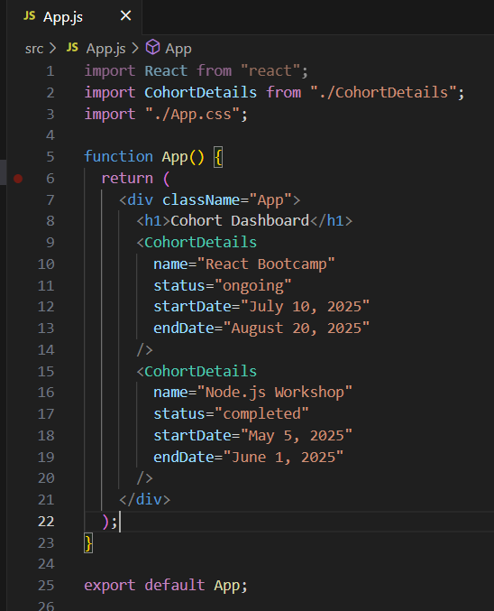

import React from "react";

import CohortDetails from "./CohortDetails";

import "./App.css";

function App() {

  return (

    <div className="App">

      <h1>Cohort Dashboard</h1>

      <CohortDetails

        name="React Bootcamp"

        status="ongoing"

        startDate="July 10, 2025"

        endDate="August 20, 2025"

      />

      <CohortDetails

        name="Node.js Workshop"

        status="completed"

        startDate="May 5, 2025"

        endDate="June 1, 2025"

      />

    </div>

  );

}

export default App;

FINAL OUTPUT :

